System Description

Section 1: Daylighting

The primary method of lighting the building during the day time is daylighting, in which the light from the sun is used to provide light for the building. The building was oriented to maximize the amount of daylighting. Most spaces in the CSL can be lit solely with daylight 70-80% of the time due to the large windows, space planning, and multitude of technologies used to reflect light deeper into the spaces. The floorplan of the CSL has been designed such that the most frequently occupied spaces are within 15 feet of windows, allowing them to be more consistently lit by daylight. Light shelves are a technology used to reflect light farther into the room, as displayed in Figure 1.



Figure 1: Light beam path with and without light shelf.

As shown in Figure 1, the light bounces off the light shelf and the ceiling and ends up further in the space. This helps areas farther from windows be lit with daylight as well. Another technology used is sloped ceilings, which, used in combination with light shelves, also help reflect light deeper into the room. Figure 2 shows a sloped ceiling being used in combination with a light shelf.

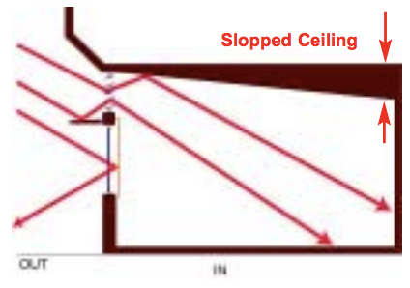

Figure 2: Light shelf and sloped ceiling

Although the CSL uses daylight for lighting, steps are taken to prevent direct sunlight from regularly falling on occupants of the building. Direct sunlight causes glare and can cause occupants to feel too much heat. Louvers and overhangs are two technologies used to prevent direct sunlight. Louvers are angled slats that allow light to enter the space without direct sunlight entering. Overhangs above windows also prevent direct sunlight from entering but block more light than louvers. Figure 3 shows an overhang with louvers above a window on the CSL building.



Figure 3: Overhang with louvers on CSL. From Phipps Conservatory.

The overhang blocks the sunlight from directly entering the space. Often overhangs and louvers are used together.

Section 2: Artificial lighting

When the daylight is insufficient, either because of night or cloudy skies, LED and fluorescent lights are used. The plan of light fixture placement and the information for each fixture can be found on the _______ page of this website. Several steps are taken to reduce electricity usage and waste when these lights are used. Occupancy sensors throughout the floors turn the lights off when no one is in the room. Dimming ballasts allow lights to be dimmed to provide only as much light is needed. Using the lighting control system discussed in the next section, different sets of lights are programmed to ensure that they are used as effectively as possible.

The building generates its own electricity to power the artificial lighting to make it a net-zero energy use building. The building’s impact on the environment is still minimized even when electrical lights instead of daylighting must be used, since the building uses renewable energy sources like solar panels. More information about the energy generation methods used to become net zero energy can be found on the ____ page of this website.

Section 3:

3.1: General monitoring and control

The lighting and systems in CSL are monitored to ensure they work correctly and note areas of improvement. A web interface allows researchers and operators to view the conditions in the building and relevant statuses of the systems at any given point in time. For example, an operator can view that the light is on even though the system is registering sufficient daylighting and start an observation of what may be malfunctioning in the building.

A key quality of any automated building is ensuring comfort of the occupants. If the occupants do not feel that the automated system is providing for their needs, they will over-ride the system. For this reason, the automation system is programmed for occupant comfort as well as energy efficiency. The Building Automation System (BAS) can change the positions of the louvers, as well as adjust the HVAC system as necessary.

3.2: Lighting Arrangement Programming

The lighting systems can be programmed in addition to being monitored. Two SpecGrade Dimming Panels are used to program the lighting arrangements for several of the main rooms in CSL (LIST OF ROOMS). The arrangements are room specific and represent a specific set of lights turned on at different settings to best accommodate a given use of the room. For example, a given room might have one set of lights that is most effective when it is being used for a conference, and a different set of lights for a presentation on a screen. This allows the most efficient lighting arrangements to be pre-determined, saving occupants’ time and aiding better lighting usage.

The scenes (arrangements) programmed in the dimming panels are linked to seeTouch wall stations in the rooms, each with two to four potential scenes. Occupants can then tap a button for which scene they want used, and the lighting will change accordingly.